**PROJECT REPORT**

A NOVEL METHOD FOR HANDWRITTEN DIGIT RECOGNITION SYSTEM

***submitted by***

***TEAM LEADER :KAVITHA D***

***TEAM MEMBER :RATHIKA***P

***TEAM MEMBER :PAVITHRA M***

***TEAM MEMBER :ABIRAMI A***

|  |  |
| --- | --- |
| TEAM ID | PNT2022TMID46204 |
| PROJECT NAME | A NOVEL METHOD FOR HANDWRITTEN DIGIT RECOGNITION SYSTEM |

-

**TABLE OF CONTENTS**

|  |  |  |
| --- | --- | --- |
|  | | **1** |
| 1.1 PROJECT OVERVIEW | | 1 |
| 1.2 PURPOSE | | 1 |
| **2 LITERATURE SURVEY** | | **2** |
| 2.1 EXISTING PROBLEM | | 2 |
| 2.2 REFERENCES | | 2 |
| 2.3 PROBLEM STATEMENT DEFINITION | | 5 |
| **3 IDEATION AND PROPOSED SOLUTION** | | **6** |
| 3.1 EMPATHY MAP CANVAS | 6 | |
| 3.2 IDEATION & BRAINSTORMING | 7 | |
| 3.3 PROPOSED SOLUTION | 8 | |
| 3.4 PROBLEM SOLUTION FIT | 9 | |
| **4 REQUIREMENT ANALYSIS** | **10** | |
| 4.1 FUNCTIONAL REQUIREMENTS | 10 | |
| 4.2 NON FUNCTIONAL REQUIREMENTS | 1  1 | |
| **5 PROJECT DESIGN** | **12** | |

|  |  |
| --- | --- |
| 5.1 DATA FLOW DIAGRAM | 12 |
| 5.2 SOLUTION & TECHNICAL ARCHITECTURE | 13 |
| 5.3 USER STORIES | 15 |
| **6 PROJECT PLANNING AND SCHEDULING** | **1**  **6** |
| 6.1 SPRINT PLANNING AND ESTIMATION | 16 |
| 6.2 SPRINT DELIVERY SCHEDULE | 1  7 |
| **7 CODING & SOLUTIONING** | **1**  **8** |
| **8 TESTING** | **20** |
| 8.1 TEST CASES | 20 |
| 8.2 USER ACCEPTANCE TESTING | 22 |
| 8.2.1 DEFECT ANALYSIS | 22 |
| 8.2.2 TEST CASE ANALYSIS | 22 |
| **9 RESULTS** | **23** |
| 9.1 PERFORMANCE METRICS | 23 |
| **10 ADVANTAGES & DISADVANTAGES** | **29** |
| ADVANTAGES | 29 |
| DISADVANTAGES | 29 |
| **11 CONCLUSION** | **30** |
| **12 FUTURE SCOPE** | **3**  **1** |
| **APPENDIX** | **32** |
| SOURCE CODE | 32 |
| GITHUB | 41 |
| PROJECT DEMO | 41 |

# CHAPTER 1

**INTRODUCTION**

#### 1.1 PROJECT OVERVIEW

Machine learning and deep learning play an important role in computer technology and artificial intelligence. With the use of deep learning and machine learning, human effort can be reduced in recognizing, learning, predictions and in many more areas.

Handwritten Digit Recognition is the ability of computer systems to recognise handwritten digits from various sources, such as images, documents, and so on. This project aims to let users take advantage of machine learning to reduce manual tasks in recognizing

digits.

#### 1.2 PURPOSE

Digit recognition systems are capable of recognizing the digits from different sources like emails, bank cheque, papers, images, etc. and in different real-world scenarios for online handwriting recognition on computer tablets or system, recognize number plates of vehicles, processing bank cheque amounts, numeric entries in forms filled up by hand (tax forms) and so

on.

# CHAPTER 2

**LITERATURE SURVEY**

#### 2.1 EXISTING PROBLEM

The fundamental problem with handwritten digit recognition is that handwritten digits do not always have the same size, width, orientation, and margins since they vary from person to person. Additionally, there would be issues with identifying the numbers because of similarities between numerals like 1 and 7, 5 and 6, 3 and 8, 2 and 5, 2 and 7, etc. Finally, the individuality and variation of each individual's handwriting influence the structure and appearance of the digits.

#### 2.2 REFERENCES

**Improved Handwritten Digit Recognition Using Convolutional Neural Networks**

**(CNN) (2020)**

*Ahlawat, Savita and Choudhary, Amit and Nayyar, Anand and Singh, Saurabh and Yoon,*

*Byungun*

This paper's primary goal was to enhance handwritten digit recognition ability. To avoid difficult pre-processing, expensive feature extraction, and a complex ensemble (classifier combination) method of a standard recognition system, they examined different convolutional neural network variations.

Their current work makes suggestions on the function of several hyperparameters through thorough evaluation utilizing an MNIST dataset. They also confirmed that optimizing hyper-parameters is crucial for enhancing CNN architecture performance. With the Adam optimizer for the MNIST database, they were able to surpass many previously published results with a recognition rate of 99.89%. Through the trials, it is made abundantly evident how the performance of handwritten digit recognition is affected by the number of convolutional layers in CNN architecture. According to the paper, evolutionary algorithms can be explored for optimizing convolutional filter kernel sizes, CNN learning parameters, and the quantity of layers and learning rates.

**An Efficient And Improved Scheme For Handwritten Digit Recognition Based On**

**Convolutional Neural Network (2019)**

*Ali, Saqib and Shaukat, Zeeshan and Azeem, Muhammad and Sakhawat, Zareen and*

*Mahmood, Tariq and others*

This study uses rectified linear units (ReLU) activation and a convolutional neural network

(CNN) that incorporates the Deeplearning4j (DL4J) architecture to recognize handwritten digits. The proposed CNN framework has all the necessary parameters for a high level of MNIST digit classification accuracy. The system's training takes into account the time factor as well. The system is also tested by altering the number of CNN layers for additional accuracy verification. It is important to note that the CNN architecture consists of two convolutional layers, the first with 32 filters and a 5x5 window size and the second with 64 filters and a 7x7 window size. In comparison to earlier proposed systems, the experimental findings show that the proposed CNN architecture for the MNIST dataset demonstrates great performance in terms of time and accuracy. As a result, handwritten numbers are detected with a recognition rate of 99.89% and high precision (99.21%) in a short amount of time.

**Improved Handwritten Digit Recognition Using Quantum K-Nearest Neighbor**

**Algorithm (2019)**

*Wang, Yuxiang and Wang, Ruijin and Li, Dongfen and Adu-Gyamfi, Daniel and Tian, Kaibin and Zhu, Yixin*

The KNN classical machine learning technique is used in this research to enable quantum parallel computing and superposition. They used the KNN algorithm with quantum acceleration to enhance handwritten digit recognition. When dealing with more complicated and sizable handwritten digital data sets, their suggested method considerably lowered the computational time complexity of the traditional KNN algorithm. The paper offered a theoretical investigation of how quantum concepts can be applied to machine learning. Finally, they established a fundamental operational concept and procedure for machine learning with quantum acceleration.

**Handwritten Digit Recognition Using Machine And Deep Learning Algorithms (2021)**

*Pashine, Samay and Dixit, Ritik and Kushwah, Rishika*

In this study, they developed three deep and machine learning-based models for handwritten digit recognition using MNIST datasets. To determine which model was the most accurate, they compared them based on their individual properties. Support vector machines are among the simplest classifiers, making them faster than other algorithms and providing the highest training accuracy rate in this situation. However, due to their simplicity, SVMs cannot categorize complicated and ambiguous images as accurately as MLP and CNN algorithms can. In their research, they discovered that CNN produced the most precise outcomes for handwritten digit recognition. This led them to the conclusion that CNN is the most effective solution for all types of prediction issues, including those using picture data. Next, by comparing the execution times of the algorithms, they determined that increasing the number of epochs without changing the configuration of the algorithm is pointless due to the limitation of a certain model, and they discovered that beyond a certain number of epochs, the model begins over-fitting the dataset and provides biased predictions.

#### 2.3 PROBLEM STATEMENT DEFINITION

For years, the traffic department has been combating traffic law violators. These offenders endanger not only their own lives, but also the lives of other individuals. Punishing these offenders is critical to ensuring that others do not become like them. Identification of these offenders is next to impossible because it is impossible for the average individual to write down the license plate of a reckless driver. Therefore, the goal of this project is to help the traffic department identify these offenders and reduce traffic violations as a result.

# CHAPTER 3

## IDEATION AND PROPOSED

**SOLUTION**

#### 3.1 EMPATHY MAP CANVAS

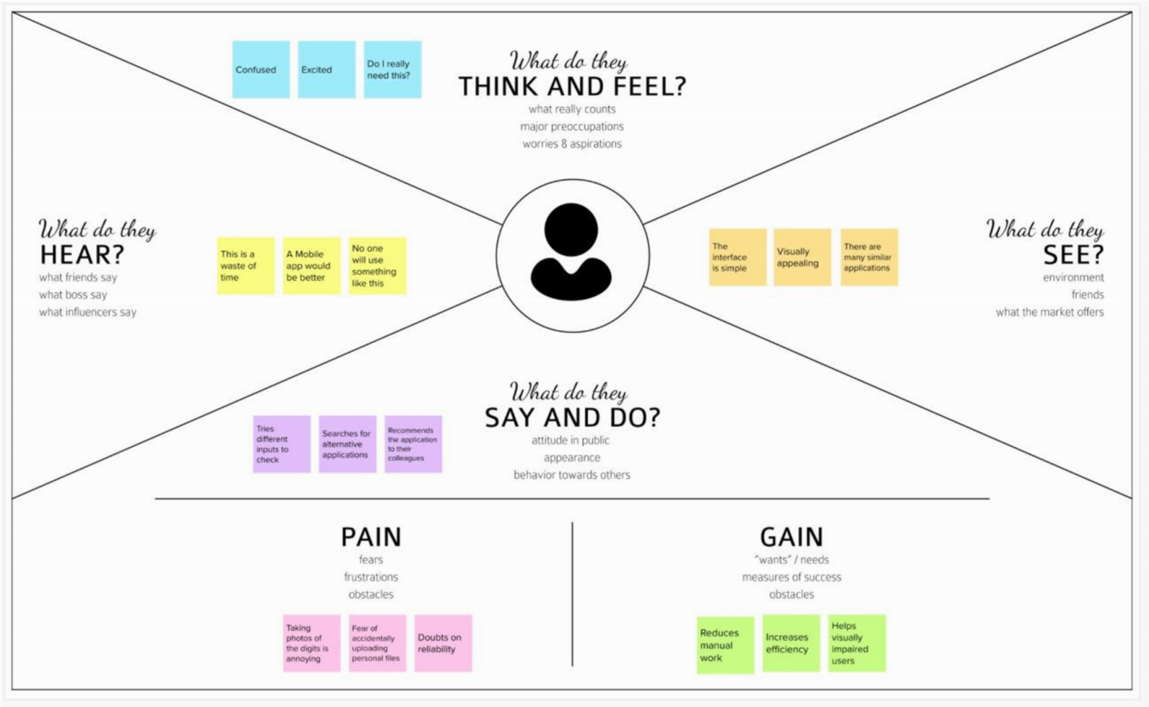

#### 3.2 IDEATION & BRAINSTORMING

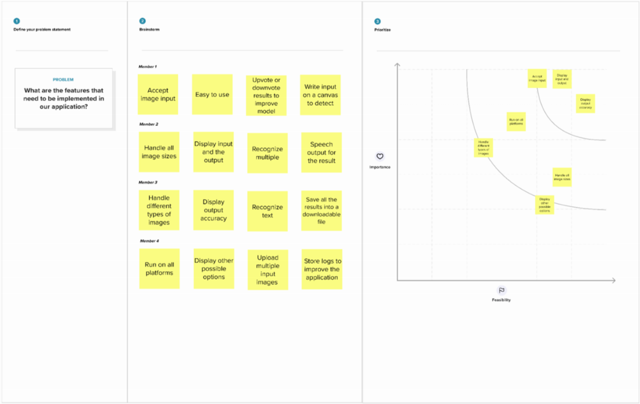

#### 3.3 PROPOSED SOLUTION

**S.NO**

**PARAMETER**

**DESCRIPTION**

1

Problem Statement

To create an application

that recognizes

handwritten digits

2

Idea / Solution Description

The

application

takes

an

the

input

and

image

as

accurately

detects

the

digits in it.

3

Novelty / Uniqueness

Instead of recognizing

every text, the application

accurately recognizes only

the digits

4

Social Impact / Customer

Satisfaction

This application reduces the

manual tasks that need to

be performed. This improves

productivity in the

workplace.

5

Business Model

The application can be

integrated

with tra

c

surveillance cameras to

recognize vehicle number

plates

The application can be

integrated with Postal

systems to recognize the

pin codes e ectively

6

Scalability of the Solution

The application can easily be

scaled to accept multiple

inputs

and process them parallelly

to further increase e

ciency

#### 3.4 PROBLEM SOLUTION FIT

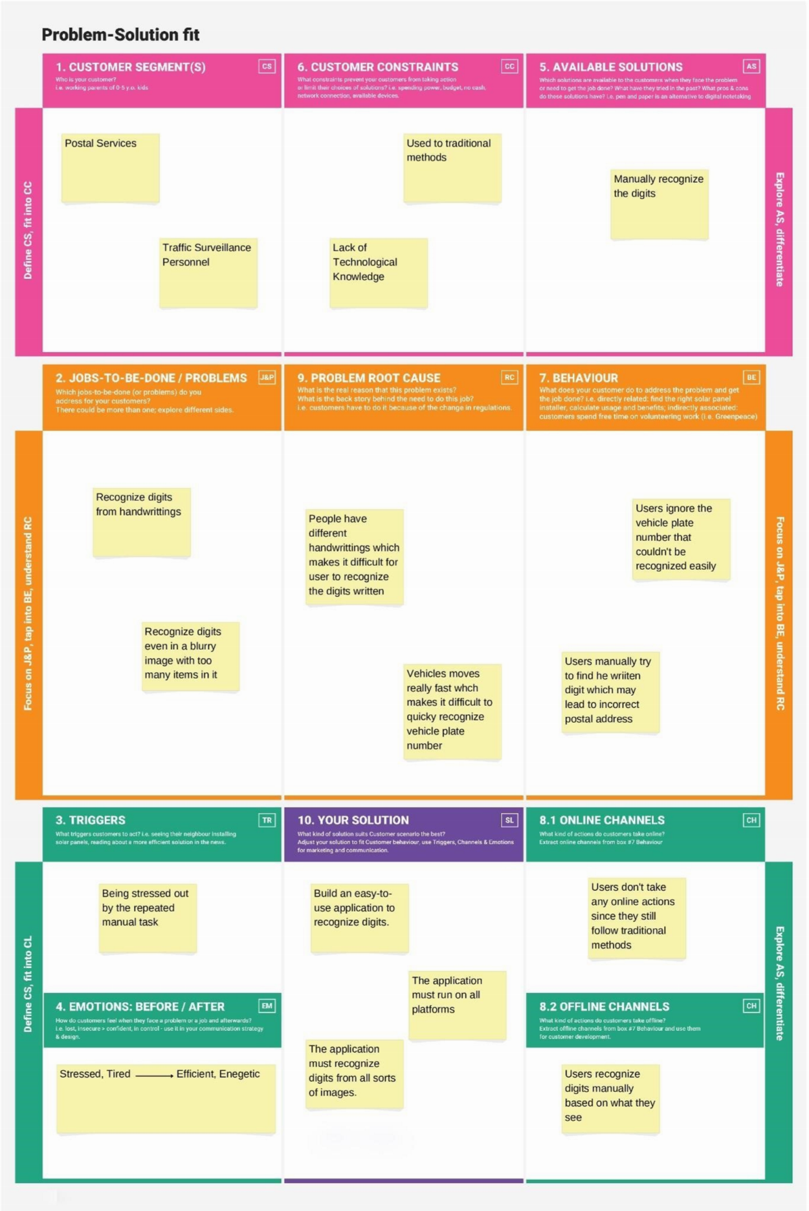

**CHAPTER 4REQUIREMENT ANALYSIS**

#### 4.1 FUNCTIONAL REQUIREMENTS

**FR.N**

**O**

**FUNCTIONAL REQUIREMENTS**

**SUB REQUIREMENTS**

FR-1

Model Creation

Get access the MNIST dataset

Analyze the dataset

Define a CNN model

Train and Test the Model

FR-2

Application Development

Create a website to let the

user recognize handwritten

digits.

Create a home page to

upload images

Create a result page to

display the results

Host the website to let the

users use it from anywhere

FR-3

Input Image Upload

Let users upload images of

various formats.

Let users upload images of

various size

Prevent users from uploading

unsupported image formats

Pre-Process the image to use

it on the model

Create a database to store all

the input images

FR-4

Display Results

Display the result from the

model

Display input image

Display accuracy the result

Display other possible

predictions with their

respective accuracy

**4.2**

**NON FUNCTIONAL REQUIREMENTS**

**NFR**

**NON-FUNCTIONAL**

**REQUIREMENTS**

**DESCRIPTION**

NFR-1

Usability

The application must be

usable in all devices

NFR-2

Security

The application must protect

user uploaded image

NFR-3

Reliability

The application must give an

accurate result as much as

possible

NFR-4

Performance

The application must be fast

and quick to load up

NFR-5

Availability

The application must be

available to use all the time

NFR-6

Scalability

The application must scale

along with the user base

**CHAPTER 5**

**PROJECT DESIGN**

#### 5.1 DATA FLOW DIAGRAM

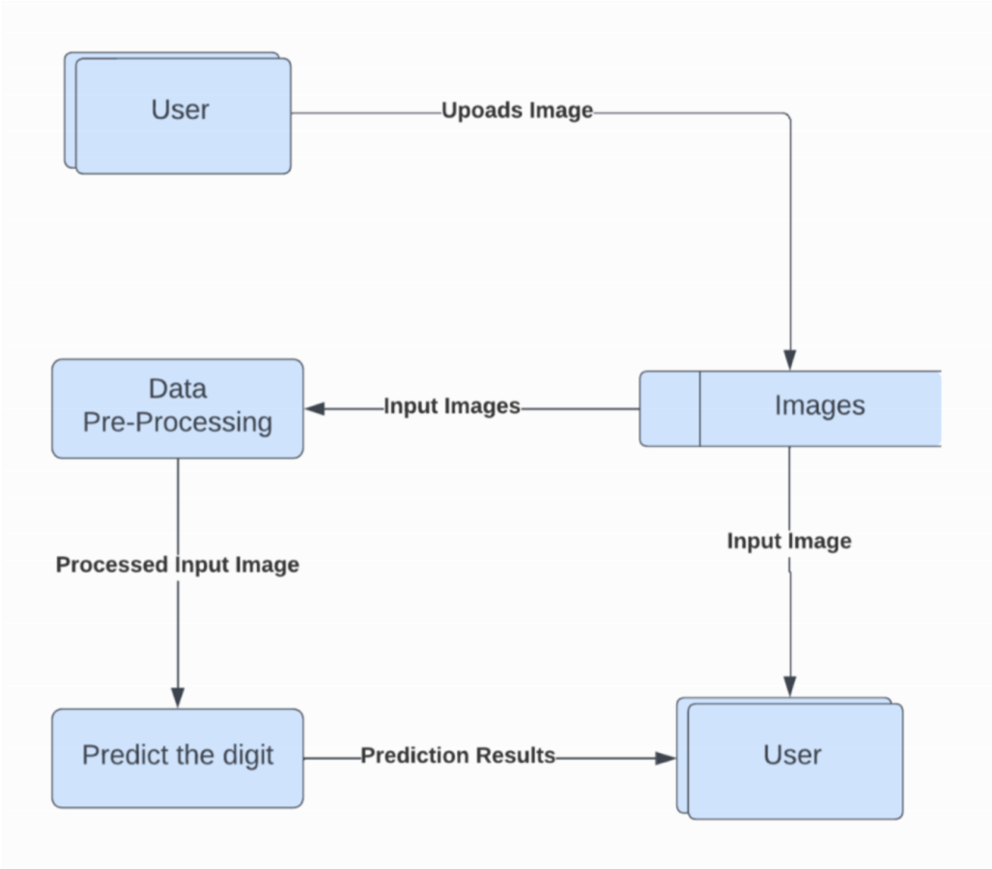

#### 5.2 SOLUTION & TECHNICAL ARCHITECTURE

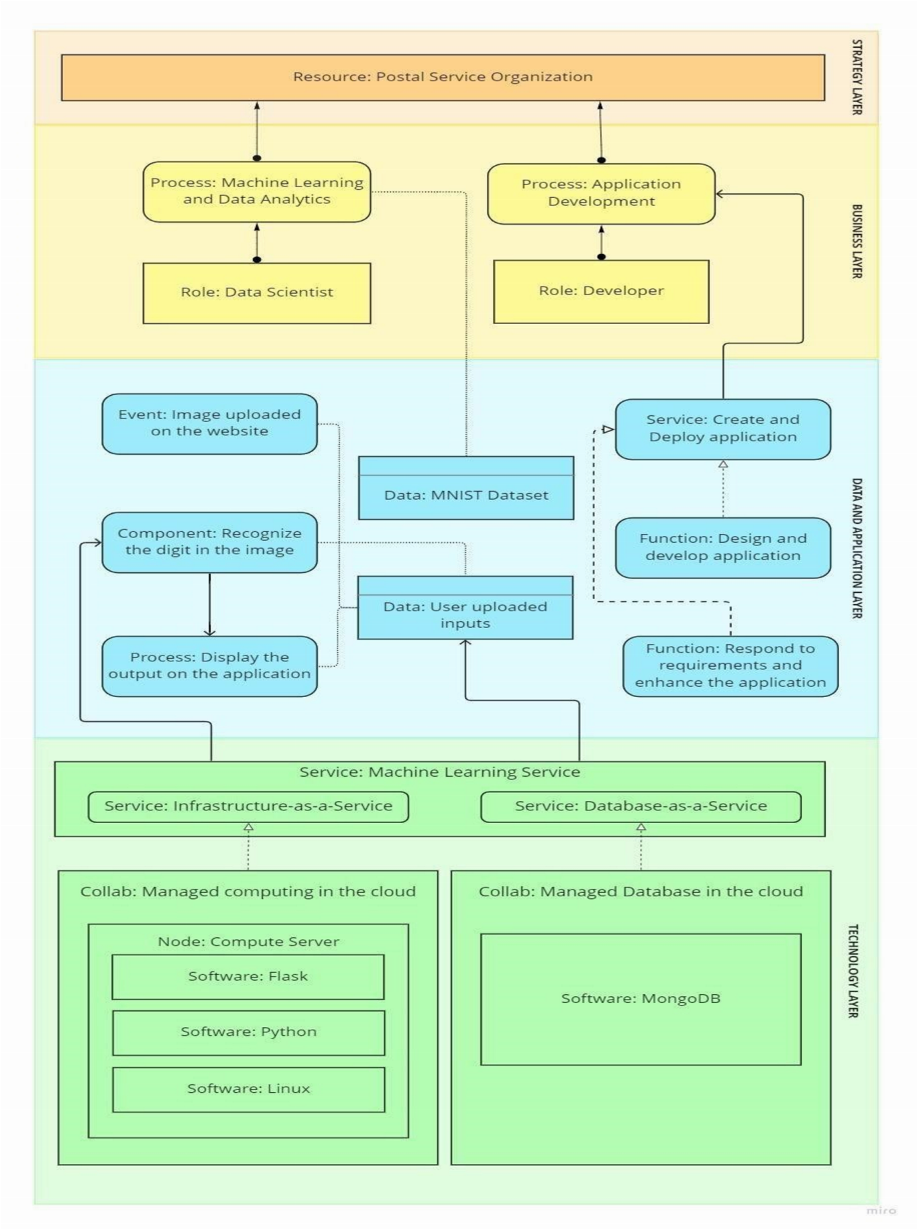

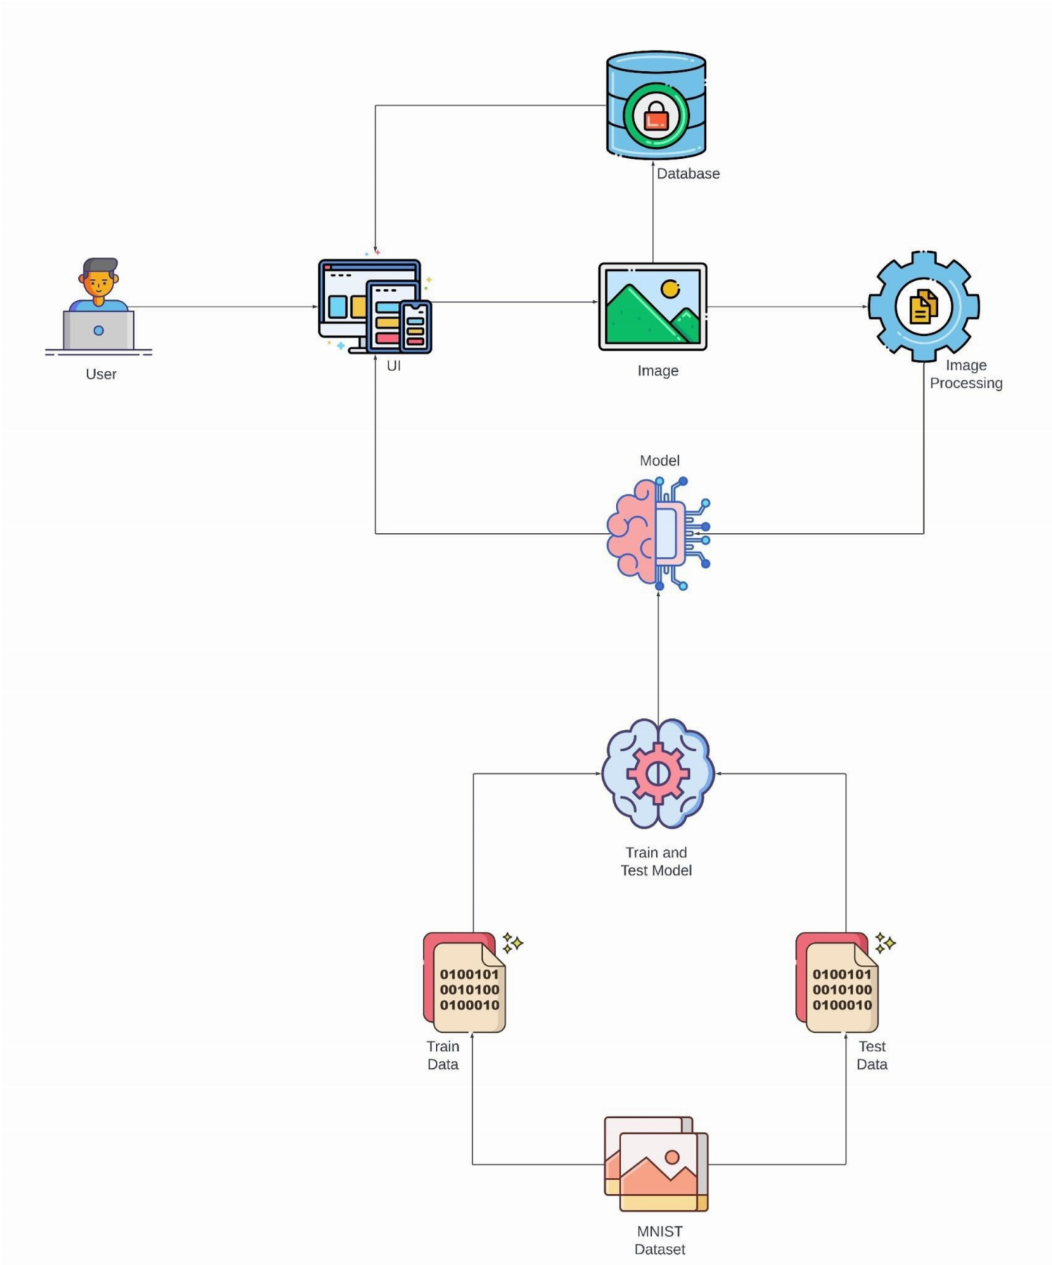

#### 5.3 USER STORIES

# 6

## PROJECT PLANNING AND SCHEDULING

#### 6.1 SPRINT PLANNING AND ESTIMATION

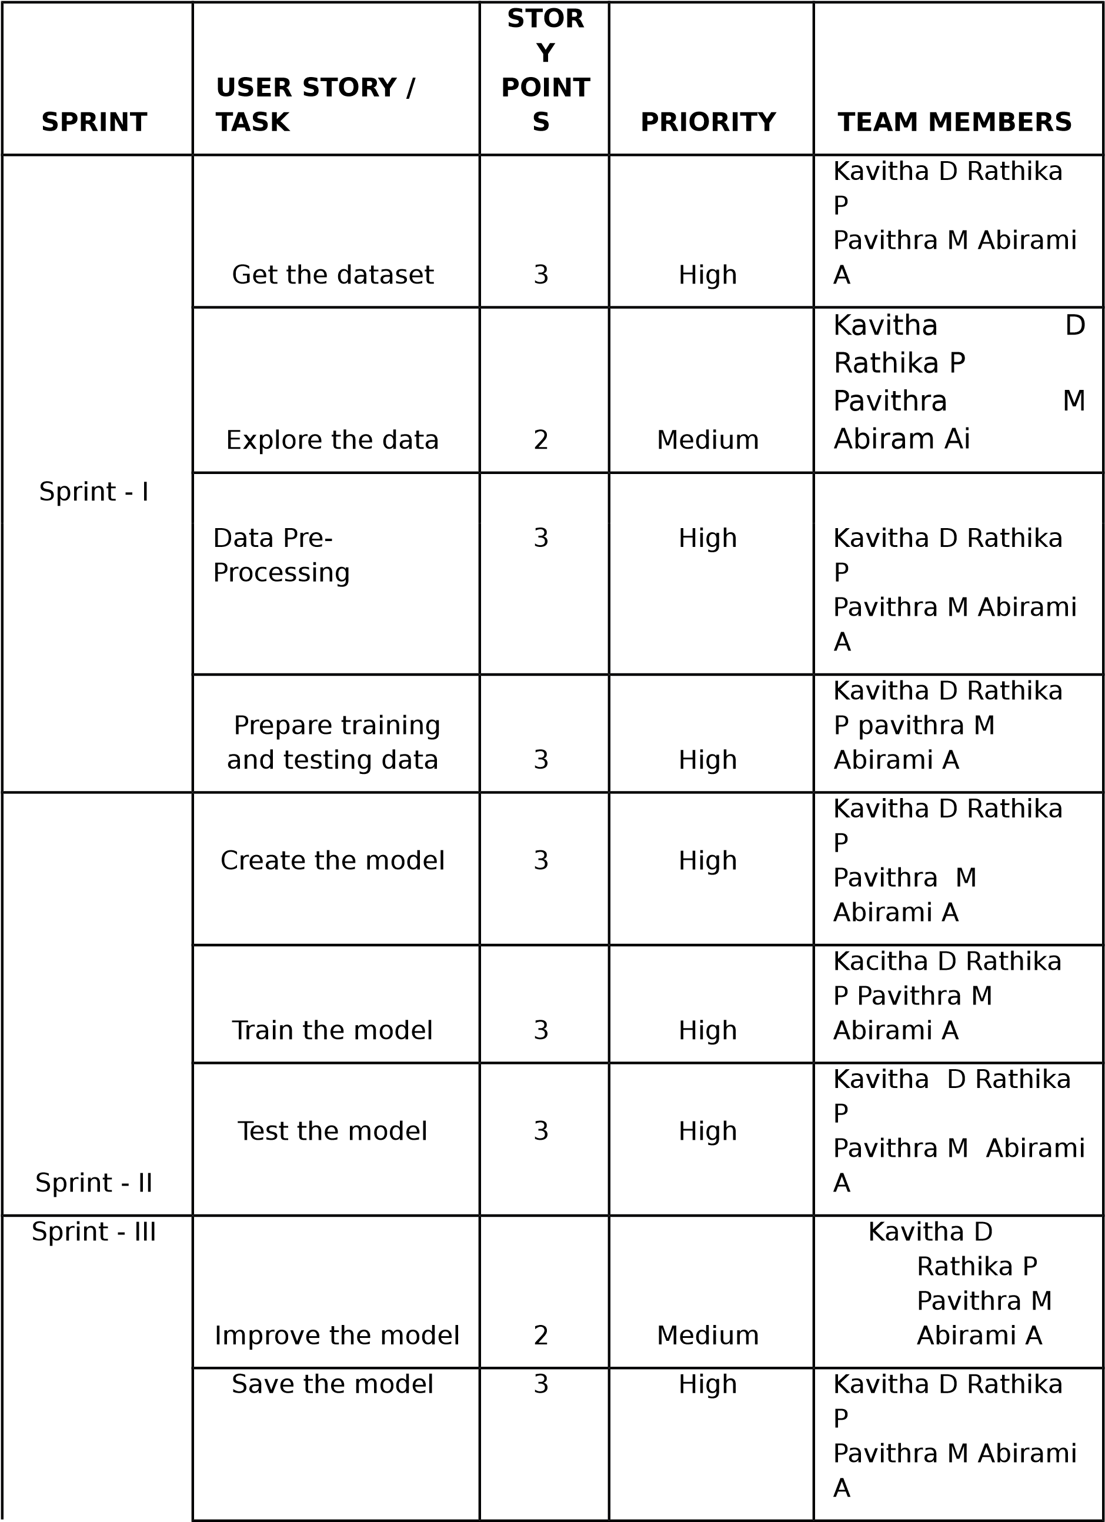

Build the Home

Page

3

High

Kavitha D Rathika

P

Pavithra M Abirami

A

Setup a database

to store input

images

2

Medium

Kavitha D Rathika

P

Pavithra M Abirami

A

**CHAPTER**

Sprint - IV

Build the results

page

3

High

Kavitha D

Rathika P

Pavithra M

Abirami A

Integrate the model

with the application

3

High

Kavitha D Rathika P

Pavithra M Abirami

A

Test the application

3

High

Kavitha D Rathika P

Pavithra M Abirami

A

**6.2**

**SPRINT DELIVERY SCHEDULE**

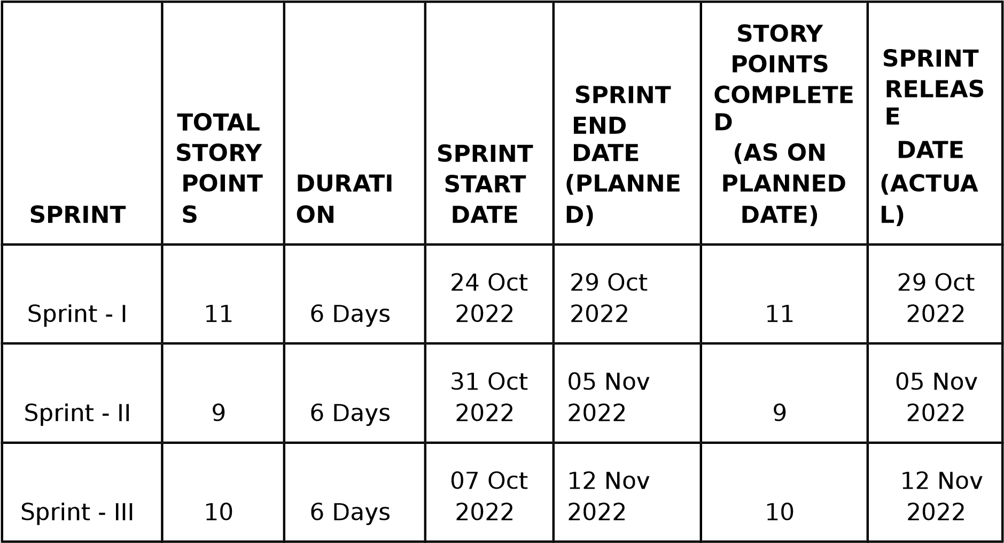

Sprint - IV

9

6

Days

14

Nov

2022

19

Nov

2022

9

19

Nov

2022

# 7

## CODING & SOLUTIONING

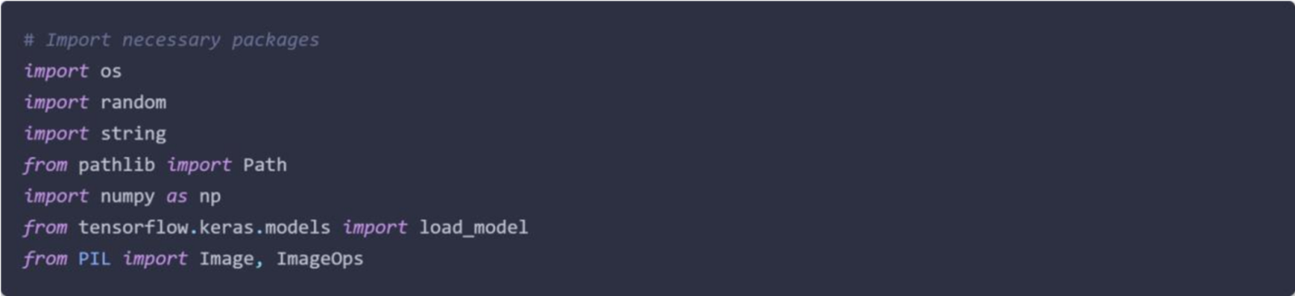

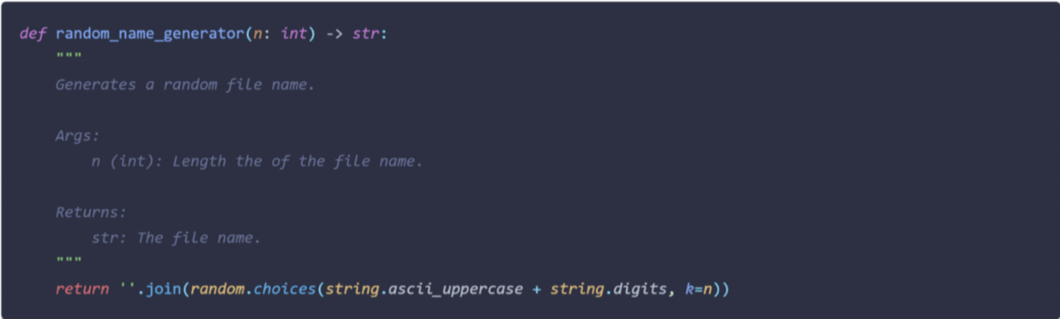

**CHAPTER**

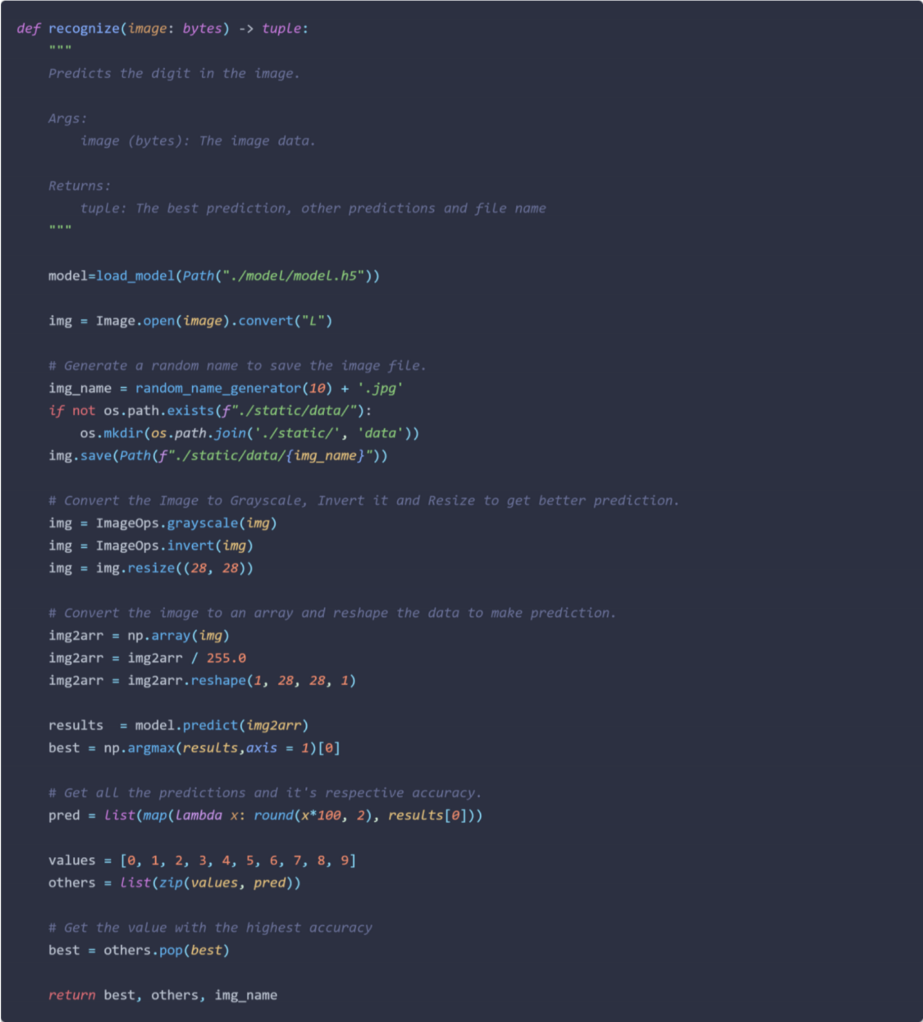

**8**

## TESTING

#### 8.1 TEST CASES

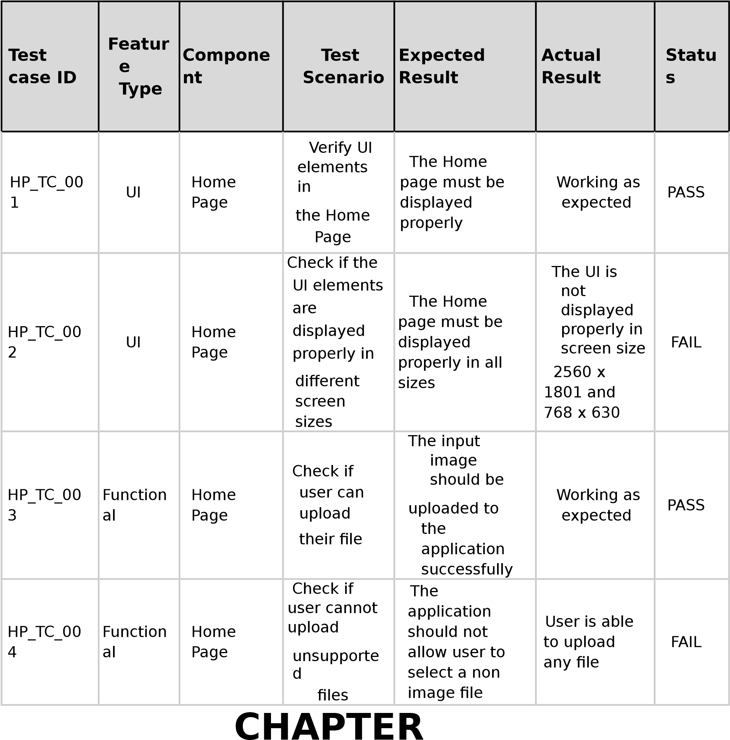

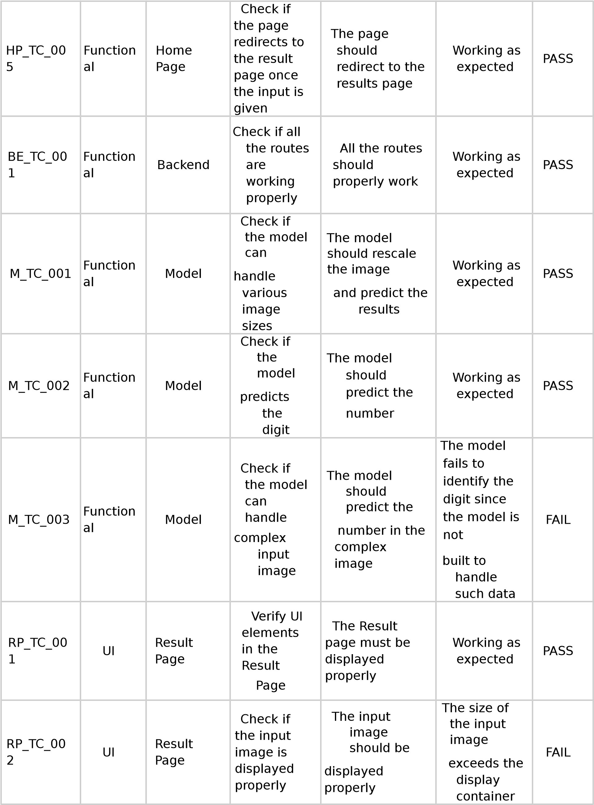

RP_TC_00

3

UI

Result

Page

Check if

the result

is

displayed

properly

The result

should be

displayed

properly

Working as

expected

PASS

RP_TC_00

4

UI

Result

Page

Check if

the

other

prediction

s

are

displayed

properly

The other

predictions

should be

displayed

properly

Working as

expected

PASS

#### 8.2 USER ACCEPTANCE TESTING

##### 8.2.1 DEFECT ANALYSIS

Section

Total

Cases

Not

Tested

Fail

Pass

Client Application

10

0

3

7

Security

2

0

1

1

Performance

3

0

1

2

Exception Reporting

2

0

0

2

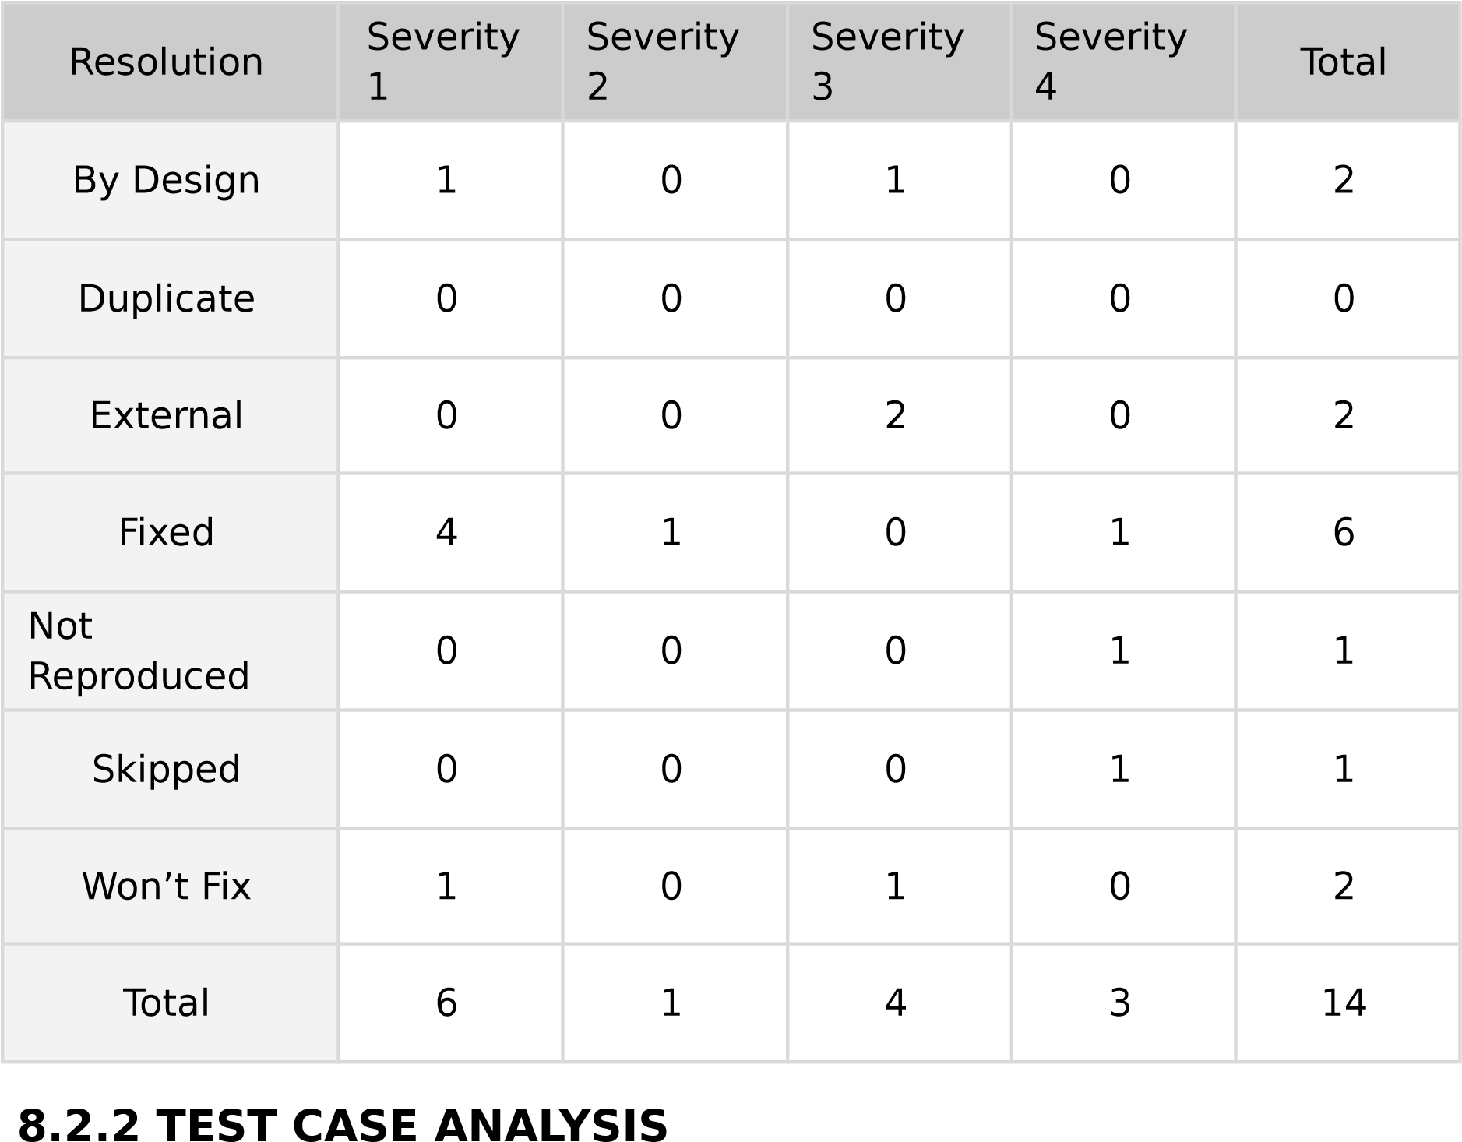

**CHAPTER 9**

## RESULTS

#### 9.1 PERFORMANCE METRICS 9.1.1 MODEL SUMMARY

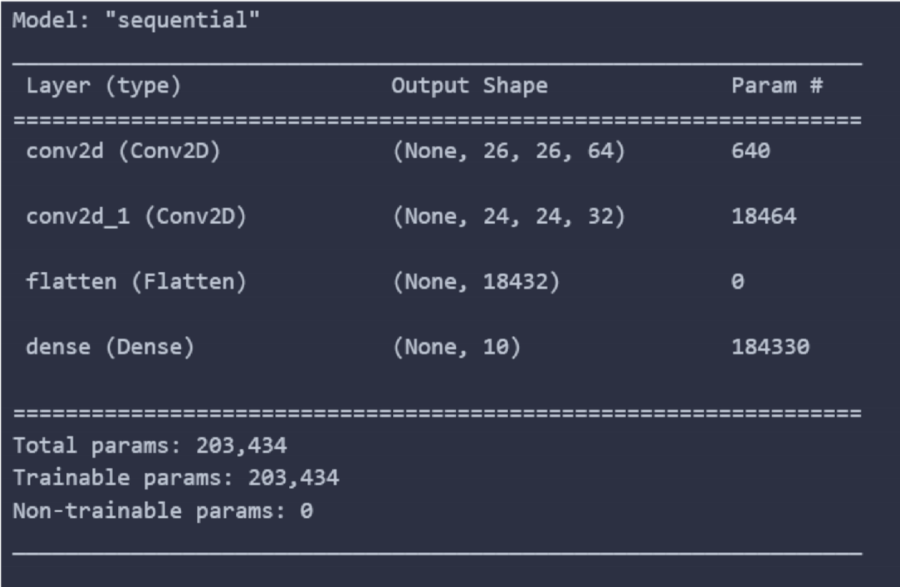

##### 9.1.2 ACCURACY

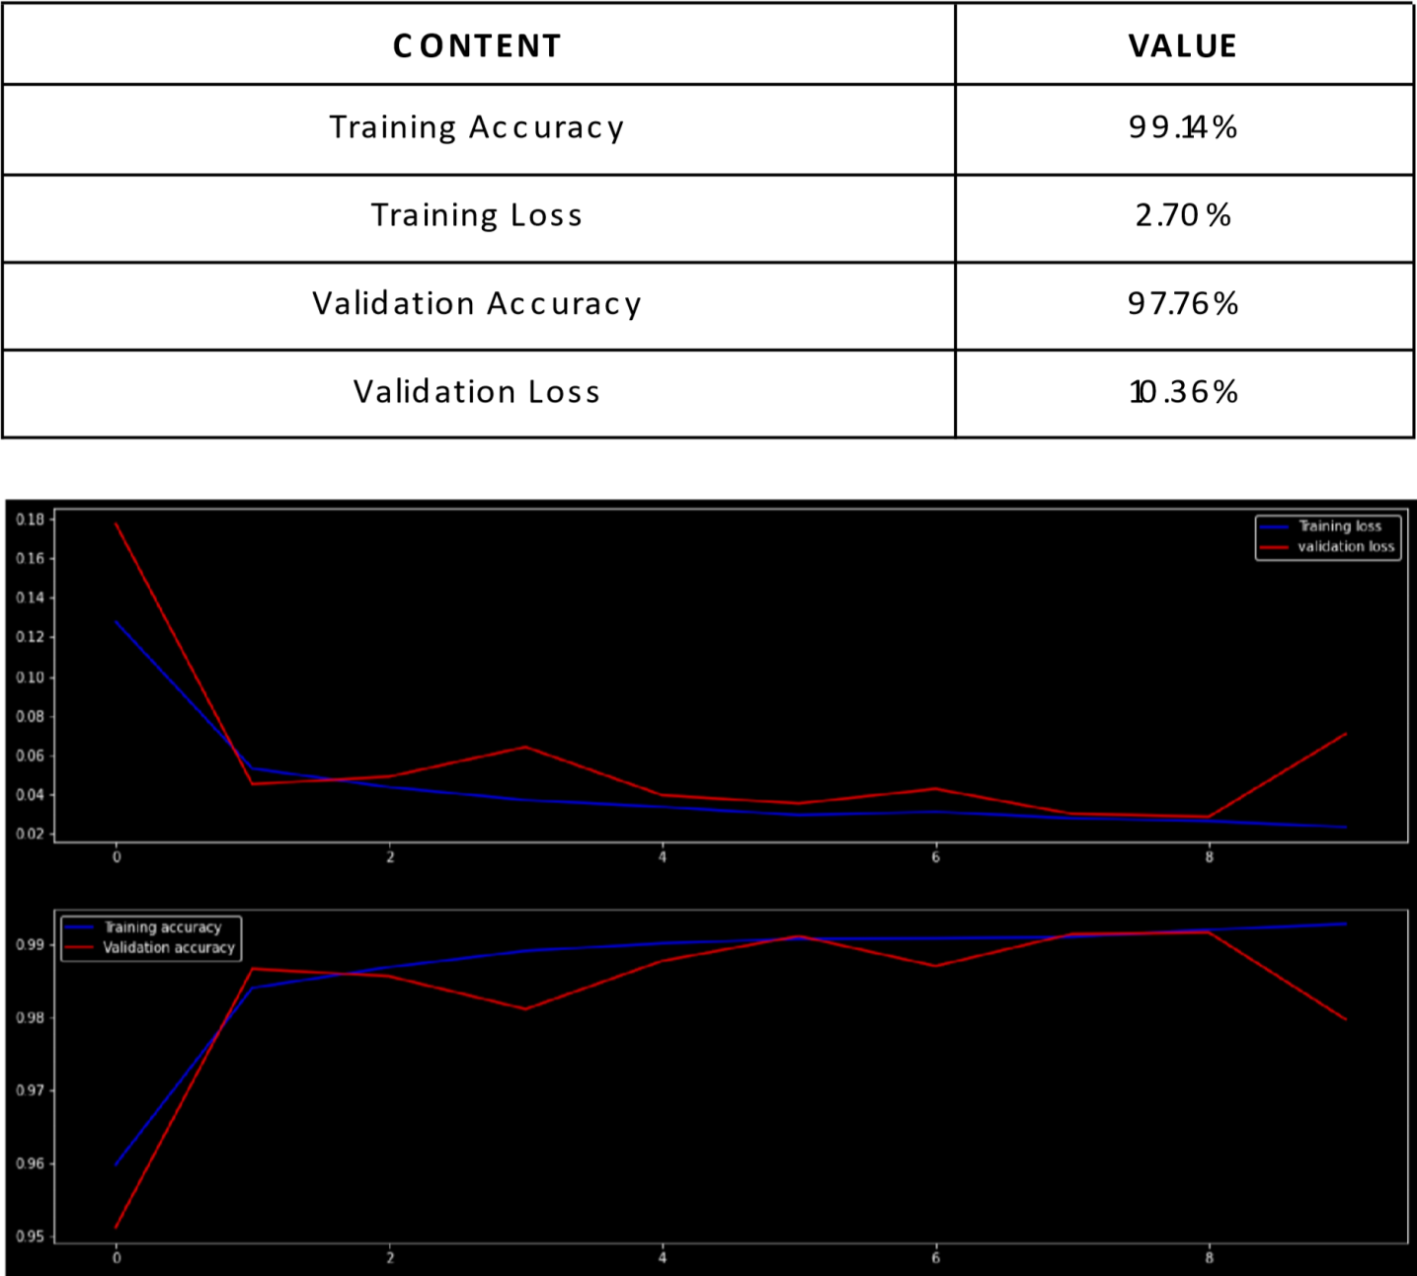

##### 9.1.3 CONFUSION MATRIX

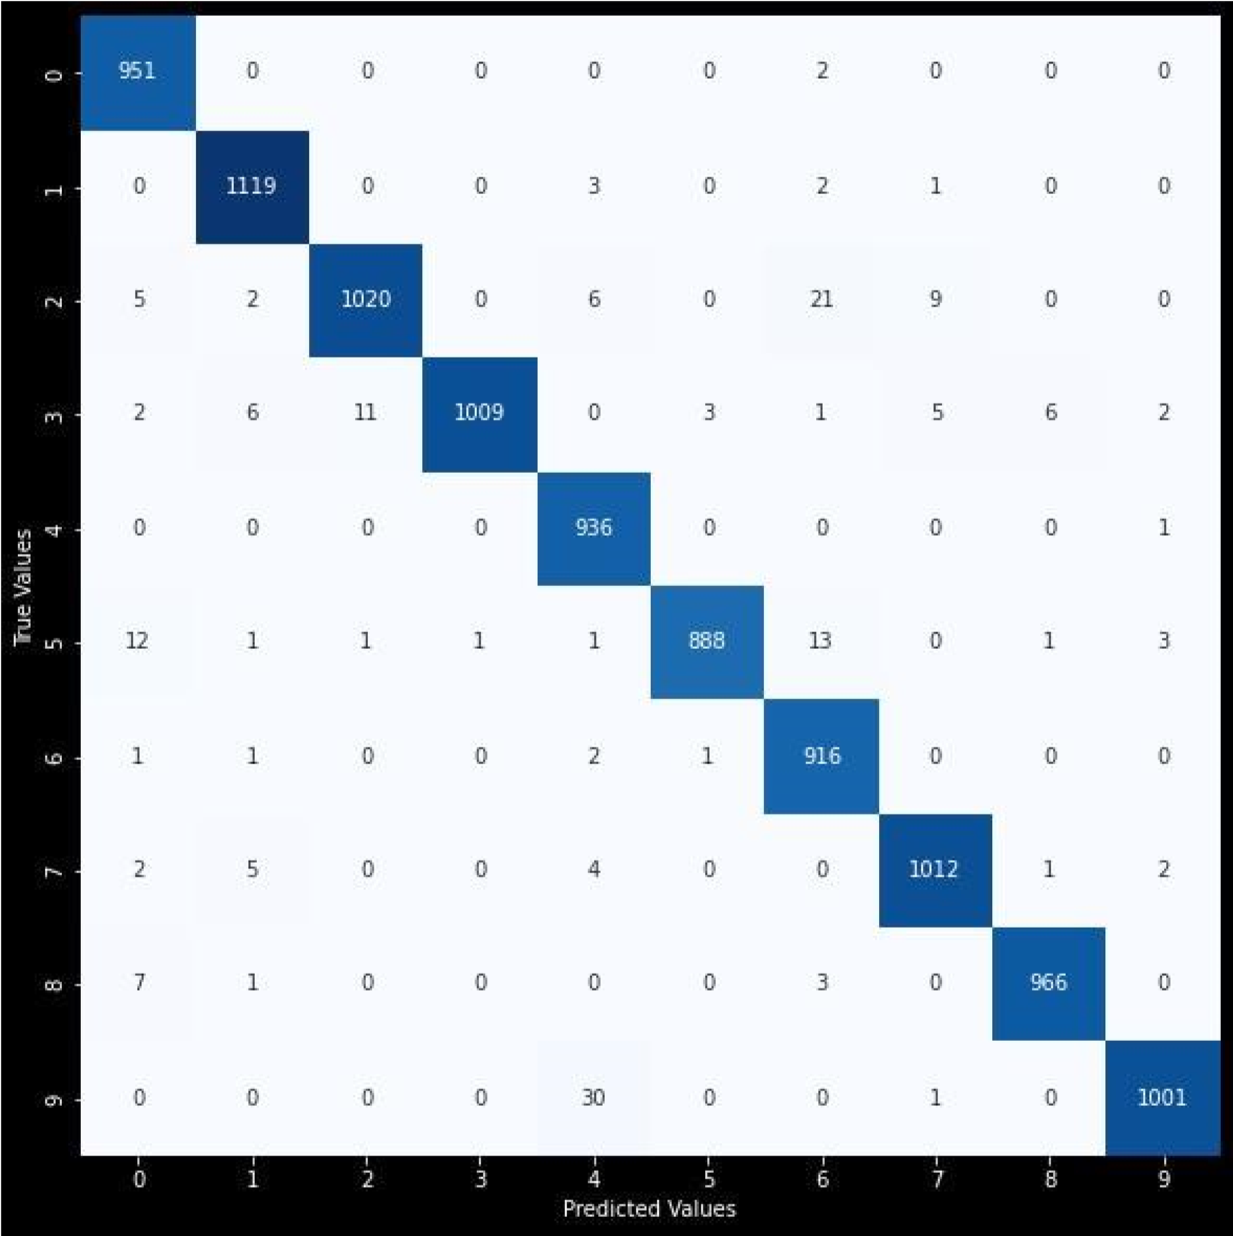

##### 9.1.4 CLASSIFICATION REPORT

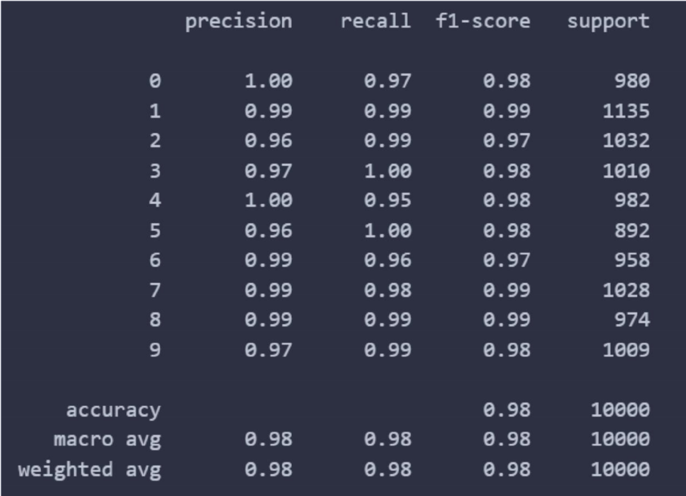

##### 9.1.5 APPLICATION TEST REPORT

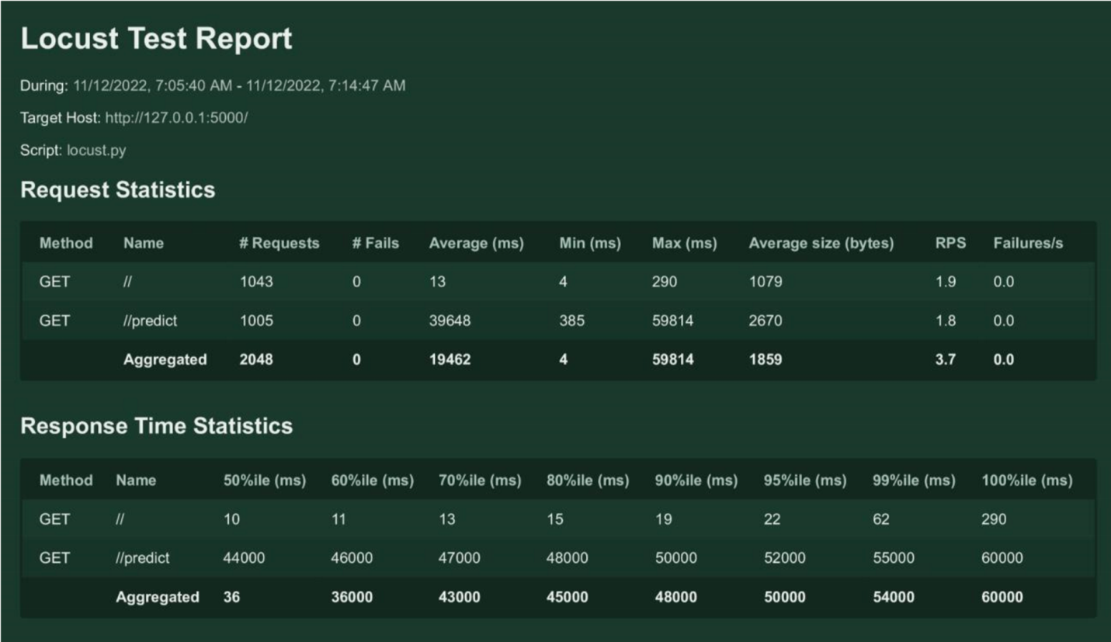

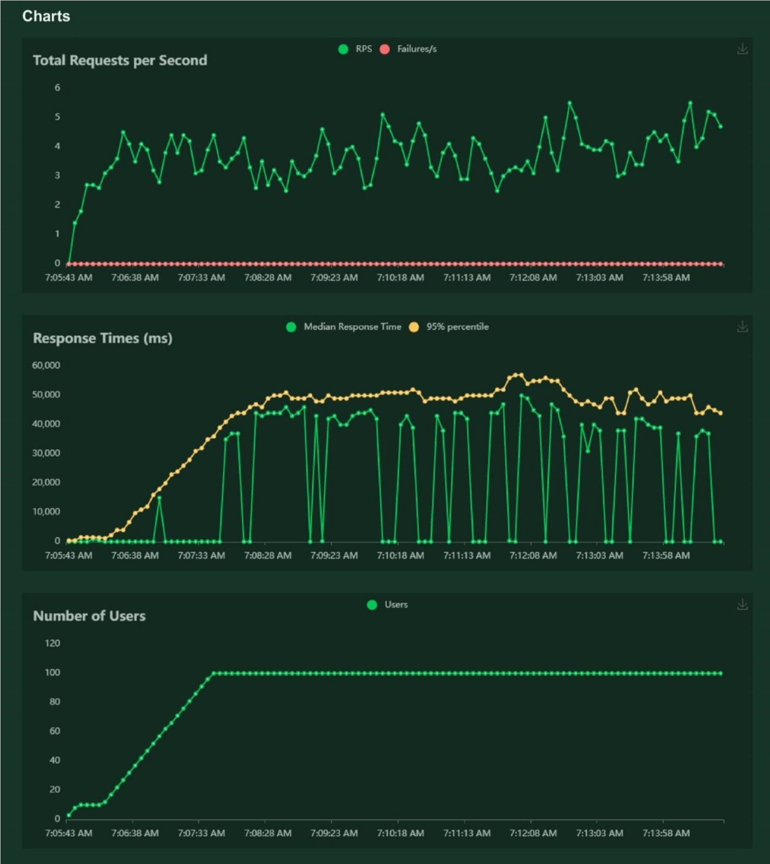

# CHAPTER 10

**ADVANTAGES &**

**DISADVANTAGES**

#### ADVANTAGES

* Reduces manual work
* More accurate than average human
* Capable of handling a lot of data
* Can be used anywhere from any device

#### DISADVANTAGES

* Cannot handle complex data
* All the data must be in digital format
* Requires a high performance server for faster predictions
* Prone to occasional errors

**CHAPTER 11**

**CONCLUSION**

This project demonstrated a web application that uses machine learning to recognise handwritten numbers. Flask, HTML, CSS, JavaScript, and a few other technologies were used to create this project. The model predicts the handwritten digit using a CNN network. During testing, the model achieved a 99.61% recognition rate. The proposed project is scalable and can easily handle a huge number of users.

Since it is a web application, it is compatible with any device that can run a browser. This project is extremely useful in real-world scenarios such as recognizing number plates of vehicles, processing bank cheque amounts, numeric entries in forms filled up by hand (tax forms) and so on. There is so much room for improvement, which can be implemented in subsequent versions.

# CHAPTER 12

**FUTURE SCOPE**

This project is far from complete and there is a lot of room for improvement. Some of the improvements that can be made to this project are as follows:

* Add support to detect from digits multiple images and save the results
* Add support to detect multiple digits
* Improve model to detect digits from complex images
* Add support to different languages to help users from all over the world

This project has endless potential and can always be enhanced to become better. Implementing this concept in the real world will benefit several industries and reduce the workload on many workers, enhancing overall work efficiency.

**APPENDIX**

**SOURCE**

**CODE**



M



O



D



E



L



C



R



E



A



T



I



O



N

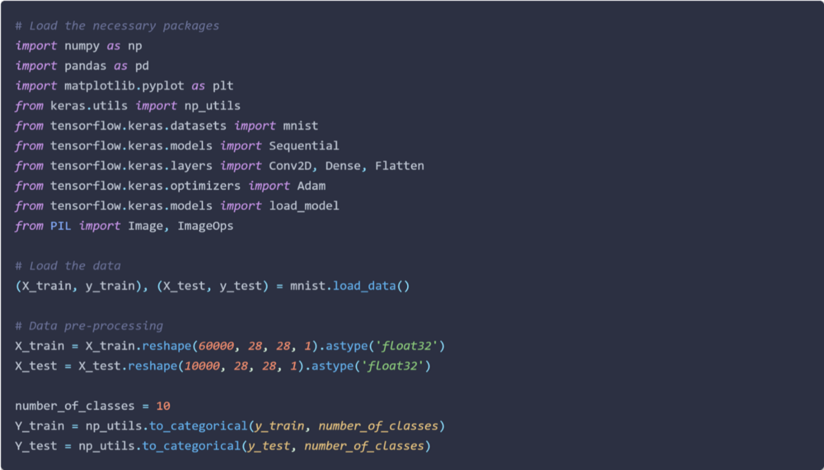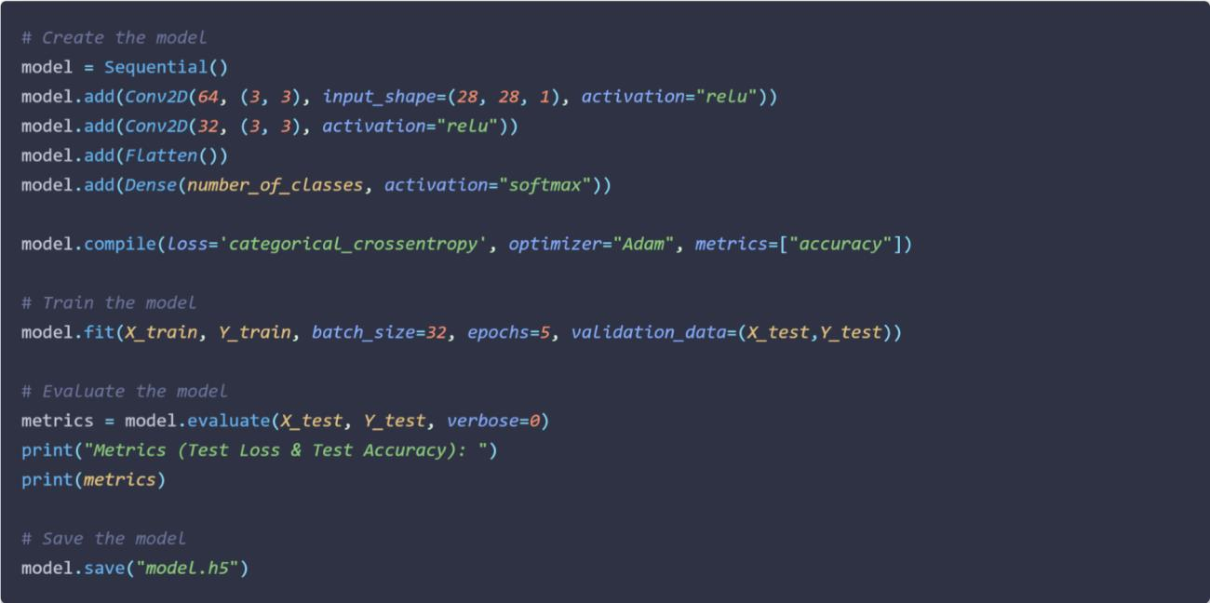

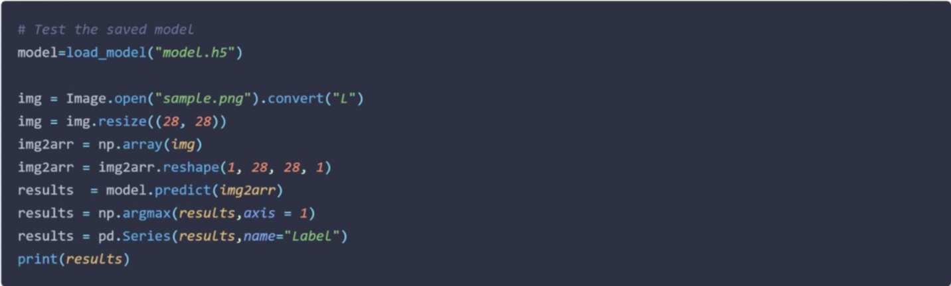

FLASK APP

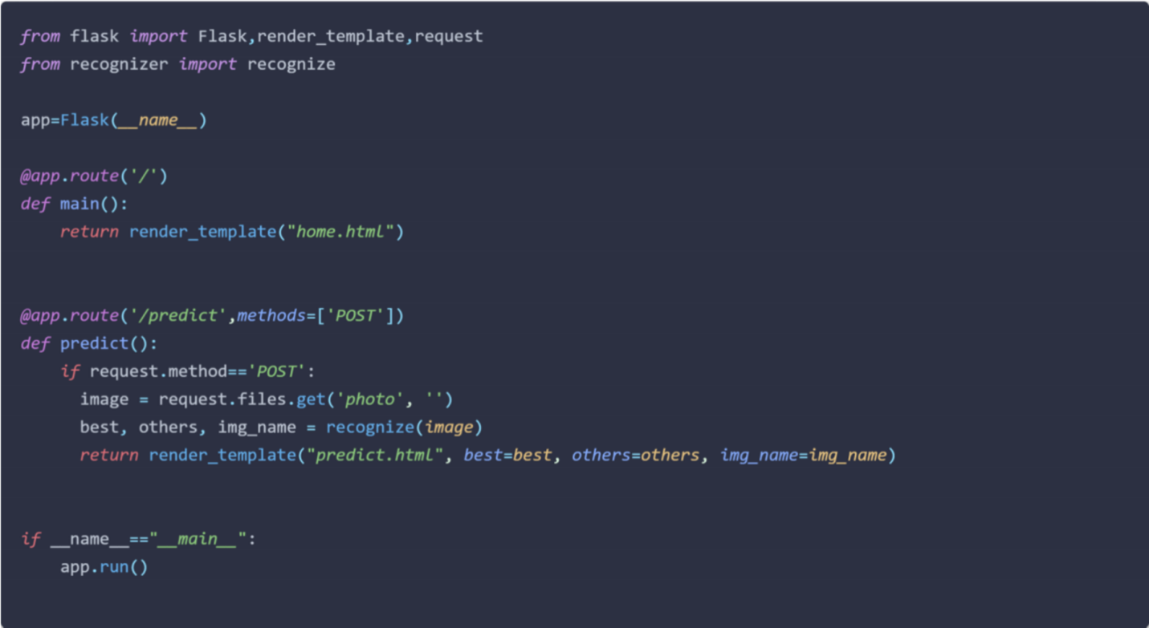

RECOGNIZER

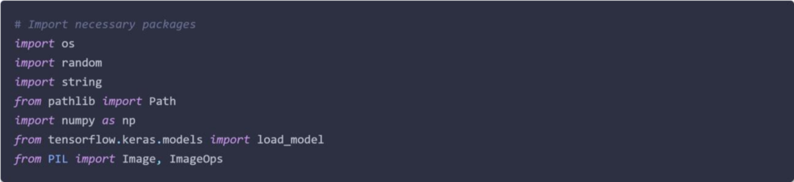

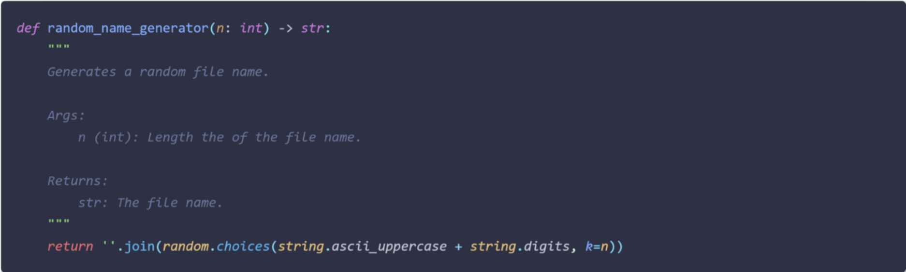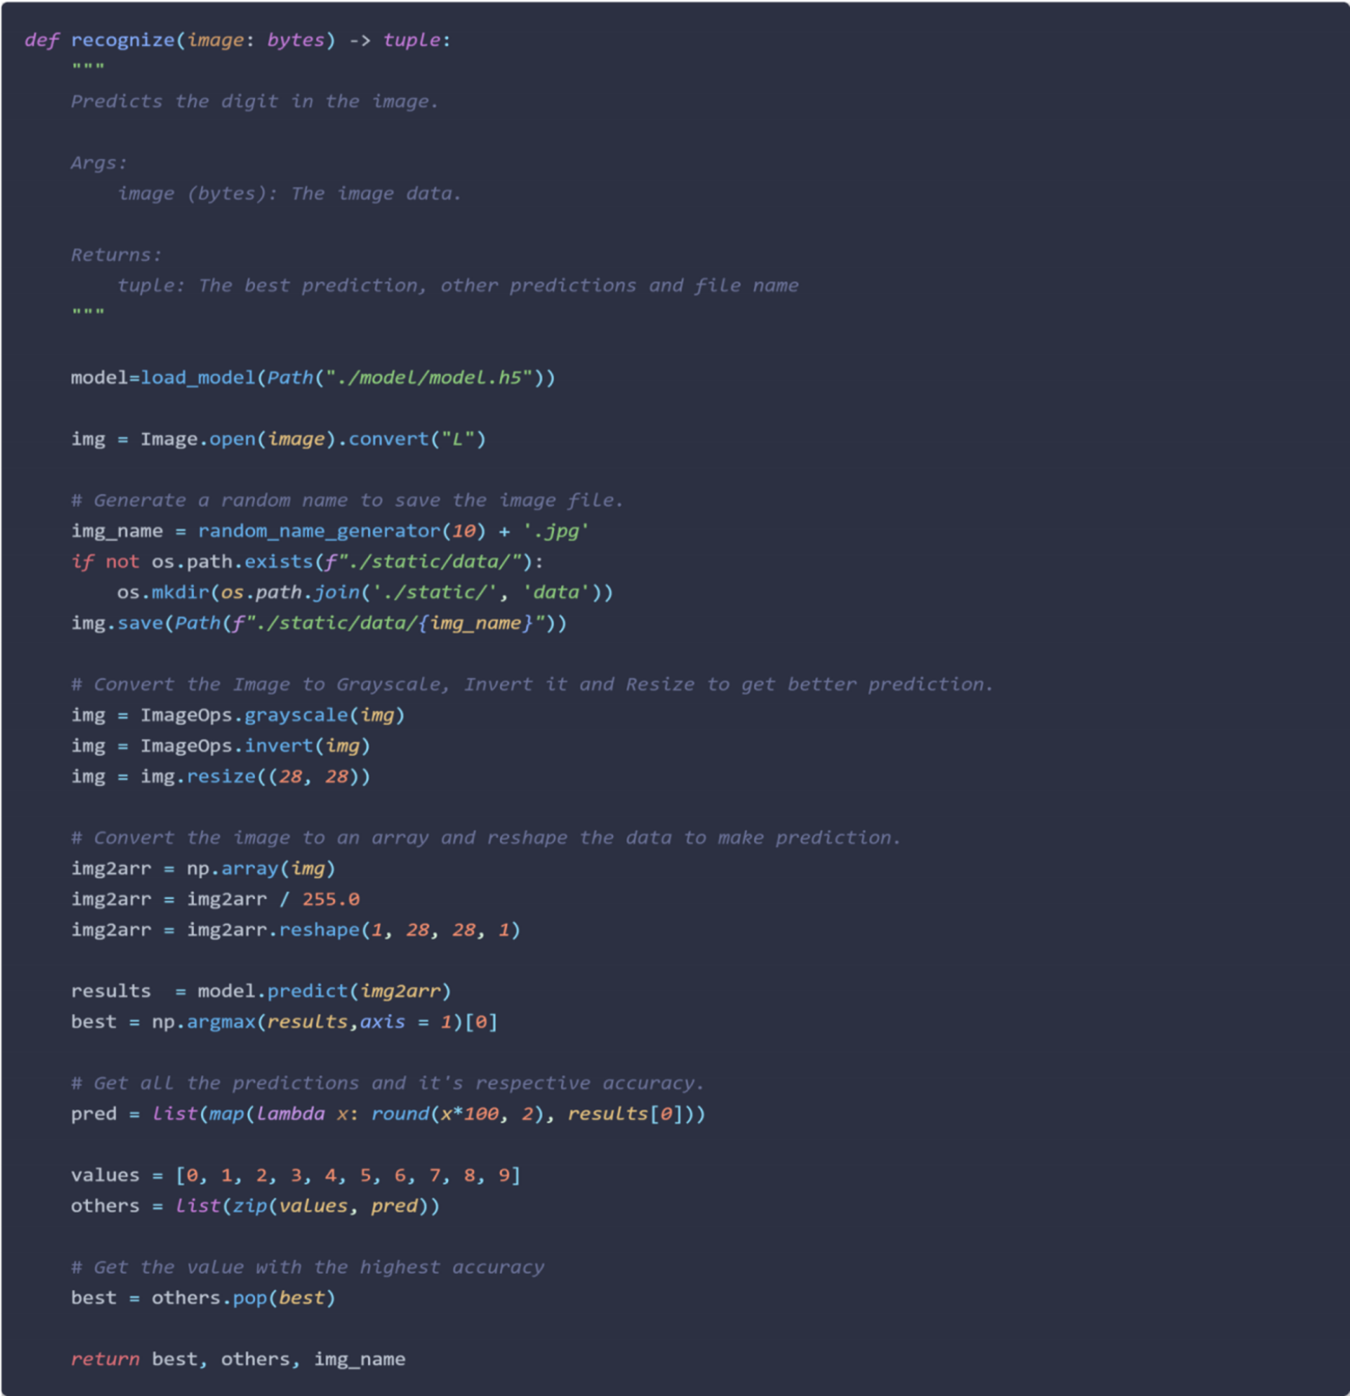

HOME PAGE (HTML)

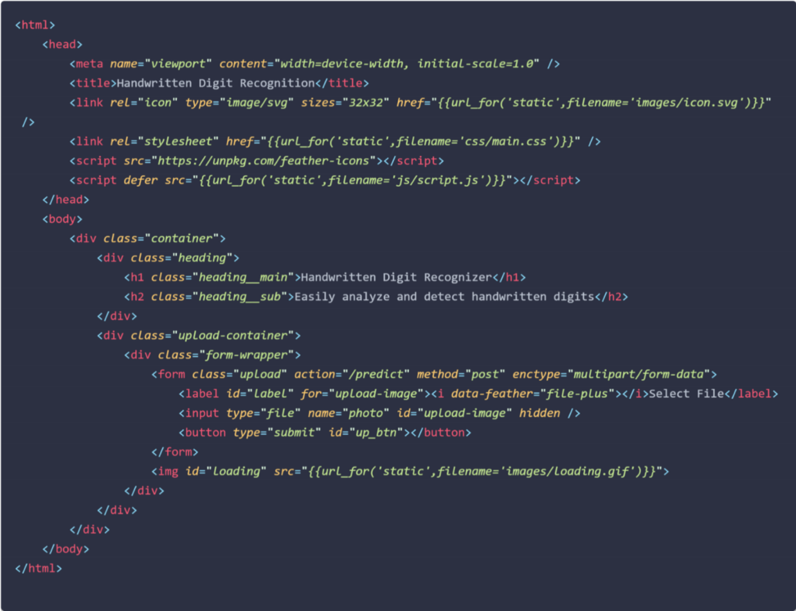

HOME PAGE (CSS)

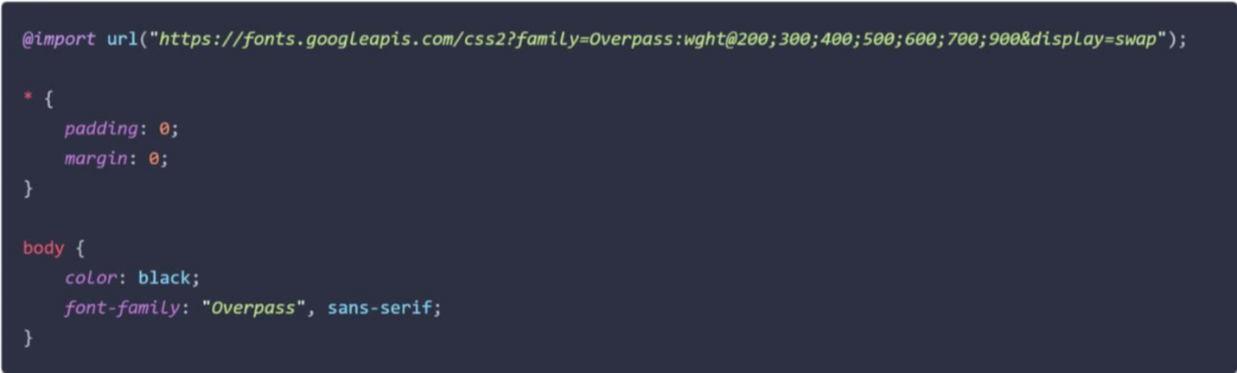

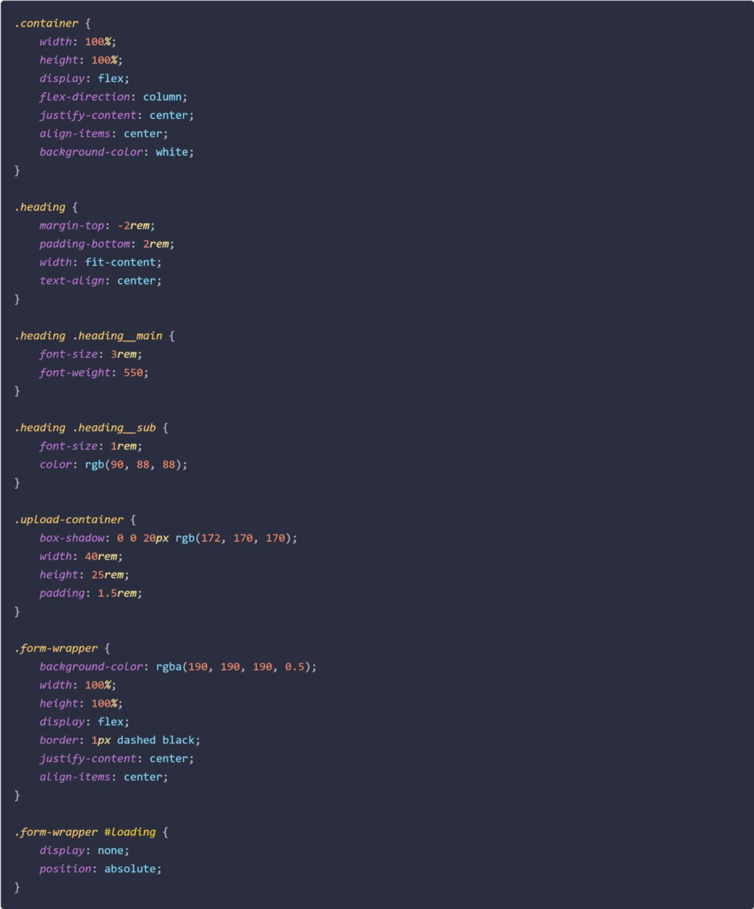

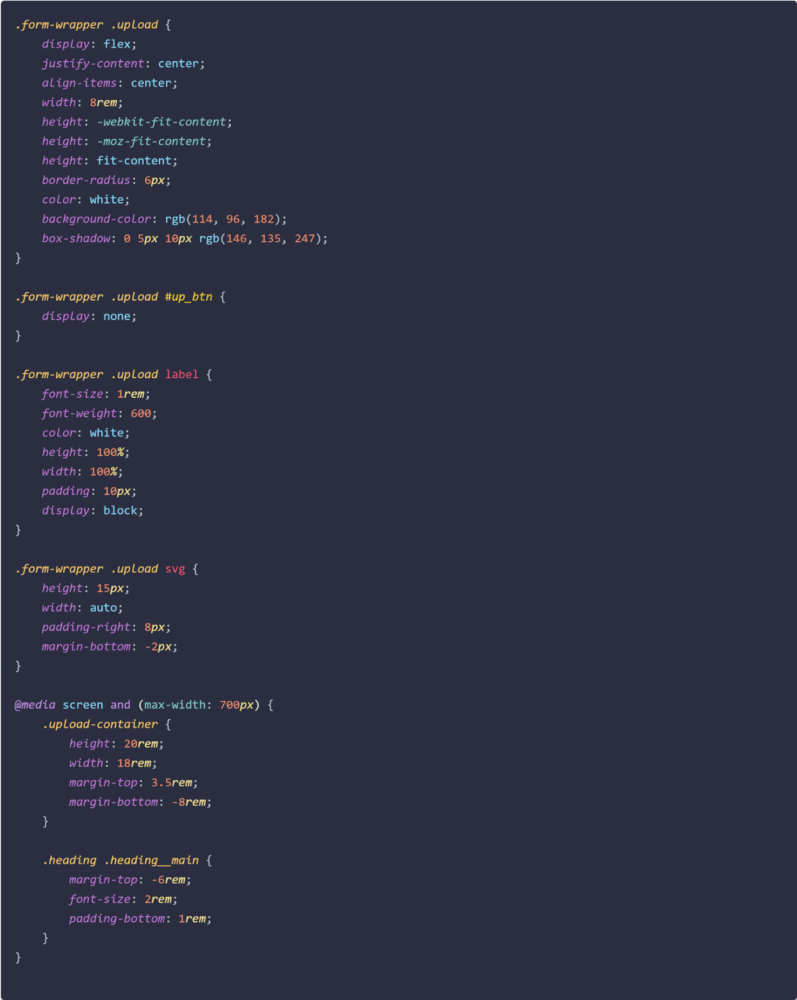

HOME PAGE (JS)



PREDICT PAGE (HTML)

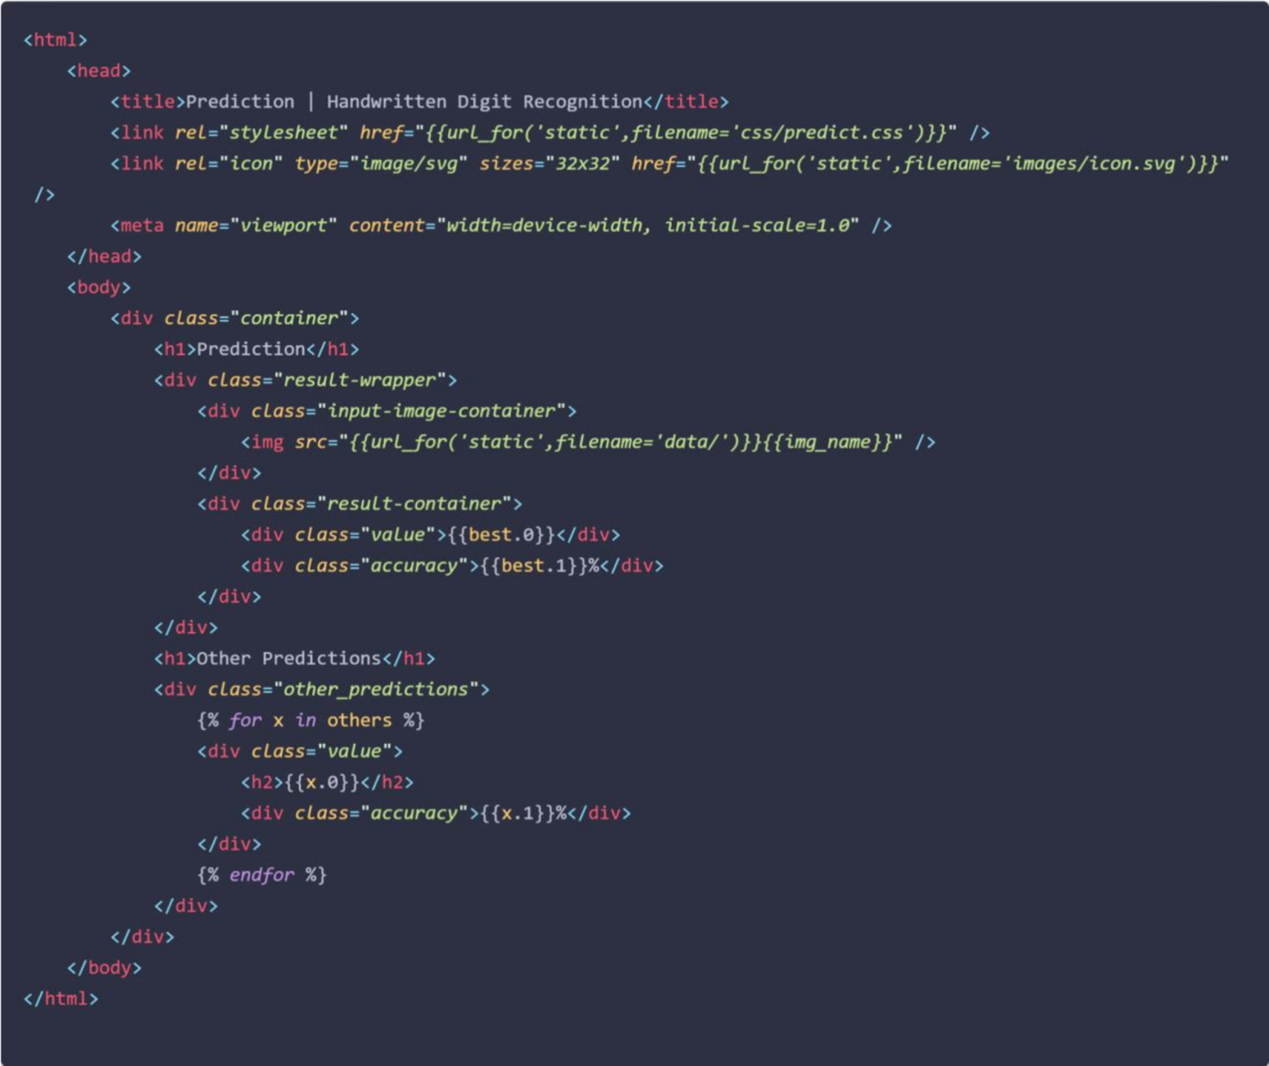

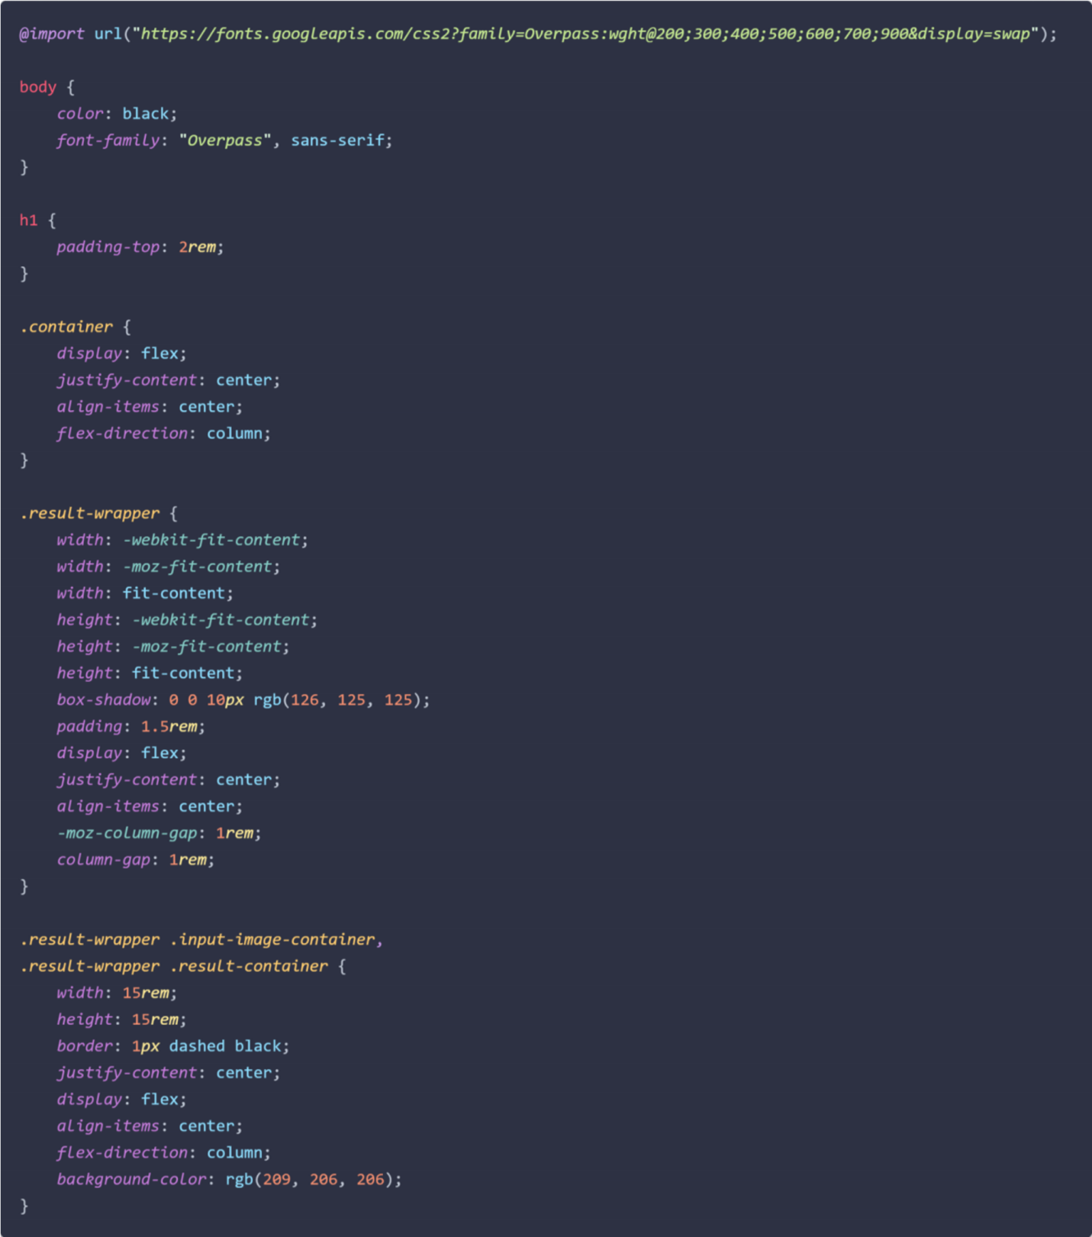

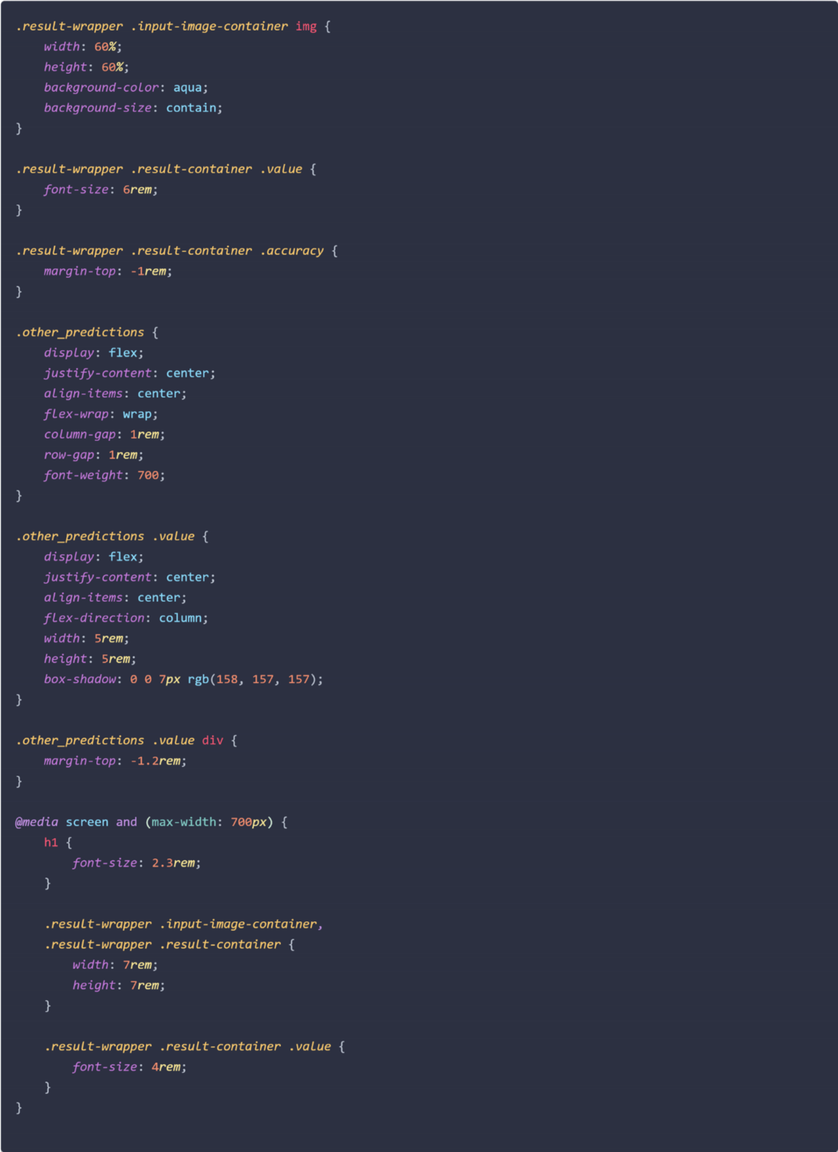

 **GITHUB** [https://github.com/IBM-EPBL/IBM-Project-133-](https://github.com/IBM-EPBL/IBM-Project-133-1658212729)

[1658212729](https://github.com/IBM-EPBL/IBM-Project-133-1658212729)

#### PROJECT DEMO

[https://www.dropbox.com/s/0tpix1k6e0uhmcr/Project%20Demo](https://www.dropbox.com/s/0tpix1k6e0uhmcr/Project%20Demo%20(PNT2022TMID37575).mp4)

[%20%28PNT2022T](https://www.dropbox.com/s/0tpix1k6e0uhmcr/Project%20Demo%20(PNT2022TMID37575).mp4)

[MID37575%29.mp4](https://www.dropbox.com/s/0tpix1k6e0uhmcr/Project%20Demo%20(PNT2022TMID37575).mp4)